Week in Review, Issue 9 - December 28-January 3
Alex Shvartsman
After a month long break, premier events are back! Here is what's coming up in our near future.

COMING UP: GRAND PRIX NEW ORLEANS

The weekend of January 6-7 opens the qualifier season for Pro Tour: Barcelona. Qualifiers (including this Grand Prix) will be held in Invasion Sealed Deck format, followed by Invasion Rochester Draft for Top 64 (or Top 8 for PTQs). Pro players who are not commonly seen at the Grand Prix circuit such as Chris Pikula, Brian Kibler and Gary Wise are planning to attend. This will be the first tournament of such magnitude held in Louisiana.

COMING UP: GRUDGE MATCH FINALS

Grudge Match tournament winners from New York and Boston will face off at the Grand Prix. The prize? $1000 and bragging rights for his home town. Among those following the Grudge Match story line, New York's Zvi Mowshowitz is heavily favored over Boston's Joe "Mouth" Kambourakis. Then again, Tom Guevin was equally favored last year, but eventually lost to New York's underdog James Bradley.
The format for this tournament will have each player build a total of 3 Type 2 decks. The trick is, they may not use more than 4 of any card except basic land for deck construction. That means a total of 4 Rishadan Ports or 4 Chimeric Idols has to be used sparingly among the three decks. The two champions will then play in the best two out of three matches to determine the ultimate victor.

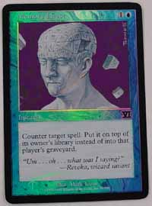
CHRISTMAS GIFT TO JUDGES
DCI sanctioned judges received a surprise Christmas gift in the mail this week. WOTC sent out a foil Memory Lapse as a way to say Thank You for their dedicated help. This is a brand new promotional card that is not currently available via any other programs such as Friday Night Magic or Arena.

YOUR MANA'S WORTH: FUN WITH MISDIRECTION
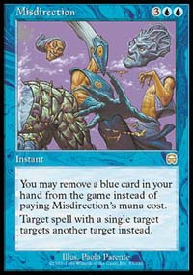
Misdirection is being actively played in both Standard and Extended formats, but it is also a card that causes quite a few rules nightmares. This week's column will attempt to answer a few very common questions about the use of Misdirection.
How exactly do I use Misdirection to counter a Counterspell?
A common error is made when a player attempts to Misdirect a Counterspell onto itself. This is not valid. A correct way to accomplish what you are trying to do is to Misdirect the Counterspell onto the Misdirection itself. This is a legal play and will amount to countering any normal Countermagic (obviously, you cannot Misdirect something like Annul to Misdirection).
If I Misdirect a Shock, when do I choose a target - on announcement or resolution?
The new target for the spell you are Misdirecting is chosen on resolution. That means you do not need to tell your opponent where you are sending his Shock until he chooses whether or not to allow your Misdirection to resolve.
What happens if I Misdirect an Unmask or Lobotomy?
While you cannot change the target of Duress or any other spell that says "target opponent," you can Misdirect cards that say "target player" such as Lobotomy and Unmask. However, your opponent is still the player who is controlling that effect. He does not have to show you his hand, nor let you choose the card for him to discard. He will make that choice. If he does not have any cards in hand that would be legal choices for the card, a judge can check and confirm that for you.
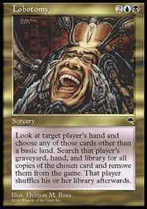
Additionally, you do not have to remove any cards, even if the Lobotomy was Misdirectioned back to you. Lobotomy requires you to choose a card from that hand that's not a basic land, and then to 'search that player's library, hand, and graveyard for cards with the same name as that card' [Oracle text], but does not actually require you to find any of them - not even the one you originally chose.
If I Misdirect a Disrupt onto Misdirection, does caster of Disrupt get to draw a card?
No. Misdirection will resolve and be removed from the stack before Disrupt attempts to resolve. Since Disrupt will no longer have a valid target, it will be countered and its caster will not get to draw a card.
Similarly, you will not lose 3 life if you Misdirect an Undermine onto Misdirection.

TRADING TRENDS
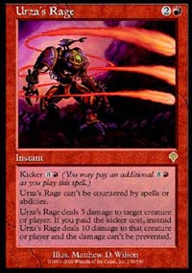
An online trading league called MOTL had an interesting idea of automatically generating the daily list of top 10 most wanted singles. As it stands now, its members really want to get their hands on:
- Urza's Rage
- Utopia Tree
- Armageddon
- Ball Lightning
- Icy Manipulator
- Serra Angel
- Pyre Zombie
- Shivan Dragon
- Blazing Specter
- Undermine
You can see their list updated regularly at www.magictraders.com


BEST OF THE NET
The "Best Article of the Week" award goes to Potato himself - Mike Turian - for his late PT Chicago report laced with some thoughts on the state of Magic and other various ideas. Mike's report can be found here.

PLAY OF THE WEEK
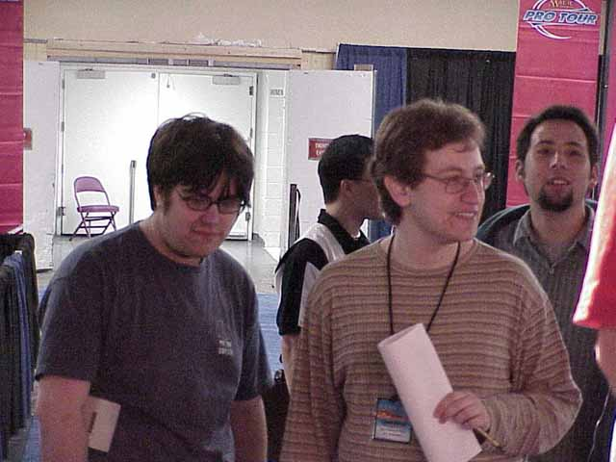
Zvi and Alex
Once more lacking in recent high-level tournaments, we journey back to the first round of the first Masters Series held at PTNY. I am playing a copy of the NecroDonate deck resurrected by the European Alliance. My opponent is Zvi Mowshowitz, who redesigned his beloved TurboLand deck for this tournament.
I've got Necropotence on the table and just drew a ton of cards, so things are grim for Zvi. Hoping to buy some time and draw some more answers, Zvi attempts to cast a Time Warp. He was not familiar with our configuration of the deck, and so my Misdirection caught him completely off guard! Having Misdirected the Time Warp to myself, I used the first turn to cast Illusions of Grandeur, and the second turn to Donate it without having to worry about any pesky Capsizes or whatever other tricks Zvi's deck may have packed.
Despite the initial shock, Zvi recovered quickly with one of the best quotes of that tournament. "I am about to say something that has never been said at this level of play," announced Zvi. "Your TURNS".

BAD PLAY OF THE WEEK
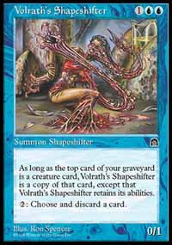
The following play was submitted by Justus Roennau, who was judging at the tournament described below.
Last week's "100 Hours of Magic" event in Germany saw many players compete in several PTQ tournaments in a row, operating on little or no sleep.
Two such players met in a matchup of Full English Breakfast vs. CounterSliver. FEB player had a pair of Volrath's Shapeshifters in play, while his opponent controlled a Crystalline and a Muscle Slivers. FEB player drew a Sliver Queen and happily activated a Shapeshifter's discard ability, turning both of his 'Shifters into copies of Sliver Queen.
He did not seem to realize that Sliver Queen is a Legend and that both Shapeshifters would immediately be buried, as two copies of the same Legendary card cannot exist in play at the same time. Fortunately for him though, his opponent conceded once he saw Sliver Queen on its way to the graveyard!
Got a Play of the Week or any other news that should be in the next week'c column? E-mail me at ashv@concentric.net

